ORCHID INTERNATIONAL COLLEGE
SET A
Bijayachowk, Gaushala-9, Kathmandu
Full Marks: 60
Time: 3 hour
Pre-Board Examination - 2080
Full Marks: 60
Time: 3 Hrs

Bachelor Level / First Year/ First Semester/ Science
Computer Science and Information Technology (CSC.111)
(Digital Logic)

Candidates are required to give their answer in their own words as far as practicable.

Group "A"

Long Answer Questions
Attempt any TWO questions [2×10 =20]

- Design a combinational circuit that generates 9’s complement of a BCD number.
- Implement the following function F = Σ(1, 2, 3, 4, 8) using
- Decoder
- Multiplexer
- PLA
- Design a counter as shown in the state diagram below.
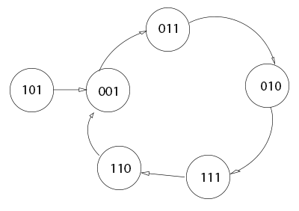

Group "B"
Short answer questions
Attempt any EIGHT questions [8×5 = 40]

- Represent -96 (negative ninety-six) 8 bits in signed magnitude, signed 1’s complement and signed 2’s complement respectively. Represent decimal number 4673 in a) octal and b) BCD.
- Express F’ = (x + y z )’ as a sum of min-terms.
- Minimize the following Boolean function using K-map:F(w, x, y, z) = wx’ + y’z’ + w’yz’ and draw logic diagram.
- Design a full subtractor using 3:8 Decoder.
- Explain the circuit and working of 4-bit parallel adder using full adders.
- Explain Positive-edge triggered R-S flip flop with necessary logic diagram and truth table.
- Define sequential circuits. Explain the working of PISO Shift register with logic diagram.
- Explain the working of Mod -7 asynchronous counter with timing diagram.
- Write short Notes on (Any two)
  - De-Morgans Theorem
  - Alphanumeric Codes
  - State Reduction
ORCHID INTERNATIONAL COLLEGE
SET B
Bijayachowk, Gaushala-9, Kathmandu
Full Marks: 60
Time: 3 hour
Pre-Board Examination - 2080
Full Marks: 60
Time: 3 Hrs

Bachelor Level / First Year/ First Semester/ Science
Computer Science and Information Technology (CSC.111)
(Digital Logic)

Candidates are required to give their answer in their own words as far as practicable.

Group "A"

Long Answer Questions
Attempt any TWO questions [2×10 =20]

- Design an odd parity generator for a 4-bit message code.
- Implement the following Functions F= Σ (0,3,5,6,8) using
- Decoder
- 4*1 Multiplexer
- PLA
- Design the sequential circuit with respect to the following state diagram using T flip flops.
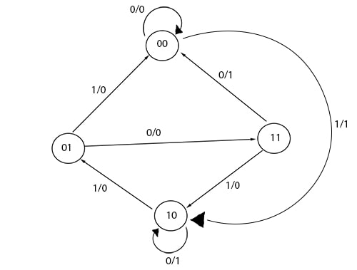
Group "B"
Short answer questions
Attempt any EIGHT questions [8×5 = 40]

- If A = 24 and B= -31, perform the arithmetic operation A+B and (-A)-B in binary using the signed -2’s-complement representation for negative numbers.
- Express the Boolean function F = x + yz as product of max-terms.
- Reduce the following function using k-map F = B’D + A’BC’ + AB’C + ABC’ and draw logic diagram.
- Design a full adder using 3:8 decoders.
- Explain the circuit and working of 4-bit parallel adder using full adders.
- Explain Positive-edge triggered J-K flip flop with necessary logic diagram and truth table.
- Define register. Explain the working of SIPO Shift register.
- Design Mod 7 synchronous counter using T flip flop.
- Write short Notes on (Any two)
- Excess-3 Code
- Duality theorem
- Excitation Table

